1. Context

1.1 System Description
Amplio is a collaborative music playlist management platform. The backend is built with .NET 8 / ASP.NET Core, the frontend is a React single-page application, and data is persisted in PostgreSQL via Entity Framework Core. Users authenticate with JWT bearer tokens.
The system currently supports user authentication, playlist creation and management, collaborative song voting, a playback queue, leaderboards, and a song catalogue.

1.2 Change Request - Friend System
The change request introduces a Friend System as a persistent social layer on top of the existing platform. Currently, users must manually share playlist join codes to invite others to their sessions. There is no way to maintain persistent social connections within the platform.
The Friend System introduces the following capabilities: users can send and manage friend requests, maintain a persistent friends list, search for other users by username, invite friends directly to playlists, and block unwanted users. Blocking hides the blocker's profile and playlists and prevents further contact.

1.3 Motivation
The Friend System increases user engagement by reducing friction in the collaborative listening experience. Without it, users must share join codes every session even with the same people. The feature enables organic discovery of friends' playlists, quick session invitations, and persistent social connections - directly addressing the core social needs of the Amplio platform's collaborative use case.

1.4 Scope of This Iteration
This document covers the requirements elaboration for the Friend System using the ICONIX process, up to and including robustness analysis. The following functional areas are in scope:
- Friend request management
- Friend discovery and viewing
- Friend-based playlist features
- Privacy and blocking

1.5 Implementation Alternatives
Three approaches were considered for implementing the Friend System:
Alternative 1 - Mutual friendship with explicit request and acceptance (chosen)
Users initiate a connection by sending a friend request; the other party must explicitly accept before a friendship is established. Either party can remove the friend or block the other at any time.

Pros | Cons
Users have full control over who can see their profile and playlists | Adds friction - both parties must act before a connection is formed
Aligns with user safety expectations on social platforms | More complex UX - users must manage incoming and outgoing requests
Enables blocking and privacy features naturally | Slower to build a social graph for new users
Persistent friend list reduces friction in repeated collaborative sessions

Risk: A user could spam others with friend requests. This is mitigated by rate limiting at the service layer and the ability to block senders.
Alternative 2 - Unidirectional follow model (e.g. Twitter/Instagram)
A user can follow another without requiring approval. The followed user's public playlists become visible to the follower immediately.
Pros | Cons
Lower friction - one action is enough to connect | No mutual consent - users may not want to be followed
Faster organic discovery of other users' content | Weaker privacy model - harder to control who sees your playlists
Familiar UX pattern for many users | Does not satisfy the requirement for mutual, persistent social connections

Risk: Without mutual consent, a user's listening activity and playlists could become visible to unwanted followers, creating privacy concerns that are difficult to address without adding a blocking mechanism - effectively reintroducing complexity comparable to Alternative 1.

Alternative 3 - Keep current behaviour (no persistent social layer)
The system remains as it is. Users connect to collaborative sessions by sharing join codes manually. No persistent friend relationships are stored.
Pros | Cons
No development effort required | Users must share join codes every session, even with the same people
No privacy concerns around persistent social data | No way to discover or invite friends outside of an active session
No new entities or migrations needed | Does not address the core motivation of the Friend System change request

Risk: If a session ends unexpectedly - due to a network drop or the host leaving - all social context is lost. Users have no way to reconnect without exchanging join codes again, creating a poor experience for regular collaborators.

1.6 Technical Constraints
The three new entities will be added to the existing AppDbContext via EF Core migrations without changes to existing tables. All new endpoints require JWT authentication. Foreign-key columns will be indexed to meet the performance targets - friend operations within 1 second, user search within 2 seconds. Rate limiting for friend requests will be enforced at the service layer.

2. Static model
This section presents the static domain model for the Amplio Friend System, developed following the ICONIX process. The domain model captures the vocabulary of the problem space in unambiguous terms - identifying the real-world objects the Friend System must reason about, their attributes, and the associations between them. It serves as the foundation from which use cases and robustness diagrams are derived. The model comprises a domain model diagram, entity descriptions, enumeration definitions, and a data dictionary

2.1 Domain model overview
The domain model captures the vocabulary of the Friend System in terms of persistent entities, their attributes, and the associations between them. Three new first-class entities are introduced - FriendRequest, Friendship, and Block - all tightly connected to the existing User entity. Two helper (supporting) enumerations (FriendRequestStatus and BlockReason) govern the lifecycle and classification of these entities.

2.1.1 Domain Model Diagram
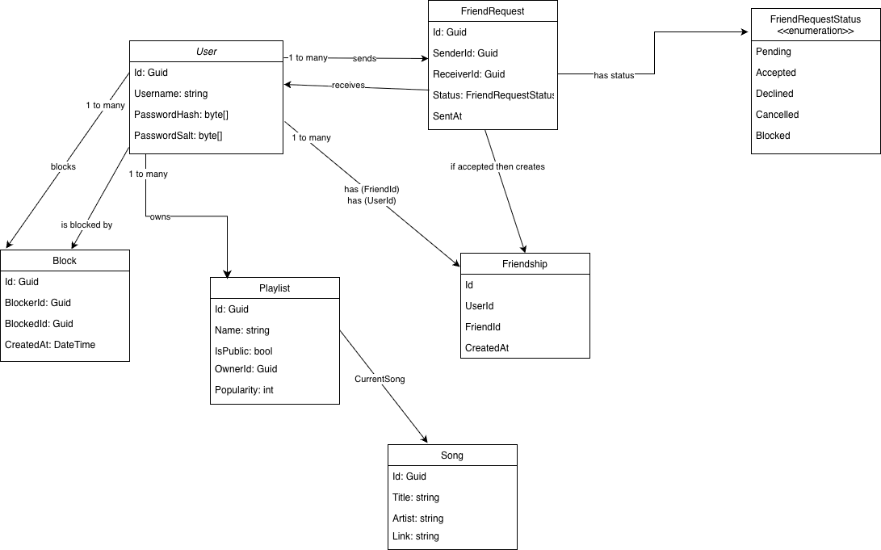

2.1.2 Domain Model Narrative
The Friend System introduces a persistent social layer to the Amplio platform, enabling users to form connections, manage friend requests, and interact with each other's playlists. The domain model captures the objects that make up this problem space. Its purpose, as Rosenberg and Stephens describe, is to understand the problem space in unambiguous terms before any use cases are written. The model presented here therefore represents the vocabulary of the Friend System as it existed after the initial domain modelling pass, before robustness analysis introduced further refinements. It is not a finished class diagram - it is a first-pass representation of the real-world objects that the system must reason about, deliberately kept free of implementation detail at this stage.
User is the central node of the domain model and the natural starting point for the narrative, because ICONIX domain modelling begins by identifying the real-world objects that already exist in the problem space. User was established in the first iteration of the Amplio domain model. It carries a unique username, credential data in the form of a password hash and salt, and a system-generated identifier. In the context of the Friend System, the same User object plays several distinct roles - sender, receiver, blocker, blocked party, and playlist owner - depending on which association is being traversed. This multiplicity of roles is a direct outcome of the domain modelling guideline to look for objects that participate in more than one relationship, rather than introducing separate specialised entities for each role.
FriendRequest is a new object discovered during this iteration's domain modelling pass. It represents the transient, lifecycle-driven record that initiates a social connection between two users. In ICONIX terms it is a domain object with a clear real-world analogue - a request sent from one person to another - and its attributes follow directly from that analogue: who sent it, who must respond, when it was sent, and what state it is currently in. The status attribute is governed by the FriendRequestStatus enumeration, which captures the full lifecycle from the initial Pending state through the terminal states of Accepted, Declined, Cancelled, and Blocked. Modelling this lifecycle explicitly as an enumeration rather than as a boolean flag is consistent with the ICONIX principle of keeping the domain model unambiguous: a boolean cannot express the difference between a request that was declined and one that was cancelled, yet that distinction drives different system behaviour. Discovering this enumeration is precisely the kind of clarification that Rosenberg and Stephens describe as the outcome of early domain modelling - moving from vague, ambiguous requirements toward concrete, tangible statements that a developer can act on.
Friendship is the durable, bidirectional social bond that comes into existence when a FriendRequest transitions to Accepted. Its appearance in the domain model reflects another core ICONIX guideline: if accepting a request and having a friendship were the same object, the model would conflate two conceptually distinct things and make the lifecycle impossible to reason about. Keeping them separate makes the "if accepted then creates" arrow in the diagram a first-class modelling decision rather than an implementation detail. The entity is intentionally minimal at this stage - two participant references and a creation timestamp - because ICONIX domain modelling defers the addition of operations and full attribute lists to the sequence diagramming phase.
Block is the third new object introduced in this iteration. It is a unidirectional enforcement record: a single Block row names a blocker and a blocked party, capturing the asymmetric social act of one user suppressing another. The decision to model Block as a first-class domain object rather than a flag on User follows from the ICONIX principle that domain objects should map to real-world concepts that have their own identity and lifecycle. A block is not merely a property of a user - it is a relationship with its own creation timestamp and its own set of downstream consequences, including the cancellation of any pending request between the parties and the deletion of any existing Friendship. The diagram shows two arrows from User to Block, labelled blocks and is blocked by, making explicit that the same User entity supplies both ends of the relationship.
The existing Playlist entity connects to the new social layer without any structural change. User already owns zero or more Playlists, and the Friend System extends this by enabling friends to be invited directly to playlists and by surfacing active playlist sessions as status indicators in the friends list. This is consistent with the ICONIX constraint that the domain model for a change request should introduce only what is genuinely new, and leave existing objects structurally untouched wherever possible.
From a process perspective, the three new entities - FriendRequest, Friendship, and Block - along with the FriendRequestStatus enumeration, represent objects discovered during the domain modelling phase of this iteration. They did not exist in the first-iteration domain model, which covered only the objects needed for playlist management, voting, and the playback queue. This feedback loop between the domain model and the robustness diagrams - where drawing the behavioural view surfaces missing objects and forces updates to the static model - is one of the defining characteristics of the ICONIX process, as described by Rosenberg and Stephens.

2.1.3 Structural summary
The diagram below is described textually in accordance with the ICONIX process. A visual UML class diagram is provided separately (above).

Entity | Category | Description
User | Existing | Authenticated platform user. Acts as requester, addressee, host, or blocked party in all Friend System relationships.
FriendRequest | New | Transient record representing one user's desire to befriend another. Progresses through a defined status lifecycle.
Friendship | New | A permanent bidirectional link is created when a FriendRequest is accepted.
Block | New | Unidirectional enforcement record prevents a blocked user from interacting with the blocker.
Playlist | Existing | Music playlist owned by a User. Can be invited via the Friend System.

2.2 Entity Specifications

2.2.1 User (existing entity)
The User entity is unchanged structurally.

Attribute | Type | Multiplicity | Description
Id | Guid | 1 | Primary key. Referenced as SenderId, ReceiverId, BlockerId, and BlockedId.
Username | string | 1 | Unique username. Used for user-search; blocked accounts are excluded from results.
PasswordHash | byte[] | 1 | Stored credential hash.
PasswordSalt | byte[] | 1 | Credential salt.

2.2.2 FriendRequest (new entity)
FriendRequest is the core transient entity of the Friend System. It is created when a user initiates a friend connection and progresses through the FriendRequestStatus lifecycle (see Section 2.3). At most one Pending request may exist between any given (Sender, Receiver) pair.

Attribute | Type | Multiplicity | Description
Id | Guid | 1 | Primary key.
SenderId | Guid (FK-> User) | 1 | User who initiated the friend request.
ReceiverId | Guid (FK-> User) | 1 | The user who receives the friend request.
Status | FriendRequestStatus | 1 | Current lifecycle state. Initial value: Pending.
SentAt | DateTime | 1 | Timestamp of request creation. Used for rate-limit enforcement (max 20/user/hr).
Constraints:
- SenderId != ReceiverId - a user cannot send a request to themselves.
- At most one Pending request may exist for a given (SenderId, ReceiverId) pair.
- A FriendRequest cannot be created if a Block record exists in either direction.

2.2.3 FriendShip (new entity)
Friendship is the durable, bidirectional social bond between two users. It is created automatically when a FriendRequest transitions to Accepted. Removing a friend deletes the Friendship record.

Attribute | Type | Multiplicity | Description
Id | Guid | 1 | Primary key.
UserId | Guid (FK-> User) | 1 | One participant in the friendship (UserId / FriendId convention as shown in diagram).
FriendId | Guid (FK-> User) | 1 | The other participant in the friendship.
CreatedAt | DateTime | 1 | Timestamp of friendship creation (i.e., when the request was accepted).
Constraints:
- UserId != FriendId.
- A unique index on (UserId, FriendId) prevents duplicate records.
- Friendship is deleted (not soft-deleted) when a user removes a friend.

2.2.4 Block (new entity)
Block is a unidirectional enforcement record. When User 1 blocks User 2, a Block record is created with BlockerId = UserId1 and BlockedId = UserId2. This prevents User 2 from sending friend requests to User 1 and hides 1's profile from 2's search results.

Attribute | Type | Multiplicity | Description
Id | Guid | 1 | Primary key.
BlockerId | Guid (FK-> User) | 1 | The user who issued the block.
BlockedId | Guid (FK-> User) | 1 | User who has been blocked.
CreatedAt | DateTime | 1 | Timestamp of block creation.
Constraints:
- BlockerId != BlockedId.
- A unique index on (BlockerId, BlockedId) prevents duplicate block records.
- Creating a Block record automatically cancels any Pending FriendRequest between the two users.

2.3 Enumeration: FriendRequestStatus
FriendRequestStatus governs the full lifecycle of a FriendRequest. The initial state upon creation is always Pending. Terminal states cannot be transitioned away from.

Value | Meaning
Pending | Initial state. The receiver has not yet responded. The sender may cancel (-> Cancelled).
Accepted | Terminal. The receiver accepted the request. A Friendship record is created atomically.
Declined | Terminal. The receiver explicitly declined. No Friendship is created.
Cancelled | Terminal. The sender retracted the request before a response. Permitted only from Pending.
Blocked | Terminal. A Block was created between the parties while the request was Pending.

State transition rules:
- Pending -> Accepted: triggered by receiver calling Accept.
- Pending -> Declined: triggered by receiver calling Decliner.
- Pending -> Cancelled: triggered by sender calling Cancel.
- Pending -> Blocked: triggered automatically when either party creates a Block record.

2.4 Entity Relationships
The following table enumerates all associations shown in the UML class diagram (higher), including multiplicities as labelled on the diagram.

Source | Relationship | Target | Multiplicity | Notes
User | sends/receives | FriendRequest | One user sends or receives zero or more friend requests | Each request has exactly one sender and one receiver.
User | has friends | Friendship | One user has zero or more friendships | A user participates in zero or many friendships via UserId/FriendId.
FriendRequest | accepted -> creates | Friendship | One accepted friend request creates zero or one friendship | Accepting a request creates exactly one Friendship.
User | blocks | Block | One user issues zero or more blocks | A user issues zero or many blocks; each Block has exactly one BlockerId and one BlockedId.
User | owns | Playlist | One user owns zero or more playlists | Existing association. A user owns zero or many playlists.
Playlist | currentSong | Song | A playlist has at most one currently playing song (or none) | Existing association. A playlist has at most one currently playing song.

2.5 Data Dictionary
The data dictionary defines all domain terms introduced by the Friend System. Terms from the base Amplio system that are unchanged are omitted.

Term | Definition
Friend Request | A user-initiated proposal to establish a persistent social connection with another user.
Friendship | A confirmed, bidirectional, persistent social bond between two users, created on acceptance of a friend request.
Block | A unidirectional enforcement record prevents the blocked user from initiating social interactions with the blocker.
Sender | The user who initiates a friend request.
Receiver | The user who receives a friend request decides to accept, decline, or ignore it.
Blocker | The user who creates a Block record against another user
Blocked User | The user against whom a Block record is created; excluded from the search results of the blocker.
Pending | FriendRequestStatus initial value: request sent, not yet actioned by the receiver.
Accepted | FriendRequestStatus terminal value: receiver agreed; a Friendship record is created.
Declined | FriendRequestStatus terminal value: receiver refused the request.
Cancelled | FriendRequestStatus terminal value: sender retracted the request before a response.
User Search | Lookup of users by username. Block records cause the blocker's profile to be excluded from the results of the blocked user.
Rate Limit | Service-layer constraint capping friend requests at 20 per user per hour to prevent abuse
JWT Bearer Token | Authentication mechanism. All Friend System endpoints require a valid JWT; unauthenticated requests receive HTTP 401.
EF Core Migration | Database schema update. FriendRequest, Friendship, and Block are added to AppDbContext via a new migration; no existing tables are changed.

2.6 Non-Functional Constraints on the Static Model
The following requirements directly constrain the design of the static model entities and their persistence.

Requirement | Impact on Static Model
User search <= 2s | Username must be indexed. Block records must be efficiently queryable by (BlockerId, BlockedId)
Friend operations <= 1s | FriendRequest status updates are single-row writes; Friendship creation is an atomic transaction.
JWT authentication required | No Friend System entity is accessible without a valid bearer token; User.Id from JWT claims resolves SenderId / BlockerId.
Rate limit: 20 req/hour | SentAt on FriendRequest enables a sliding-window count at the service layer. No additional entity required.
No existing table changes | FriendRequest, Friendship, and Block are independent tables added via EF Core migration. No existing tables are altered.

3. Use Cases

3.1 UC-01 Send Friend Request
Actors: Registered User
Preconditions:
- User is authenticated
- Target user exists
- Users are not already friends
- No block exists between the two users
Main Flow:
- User searches for another user by username
- System queries the User entity and displays results
- User clicks 'Add Friend' on a result
- System validates the request against the FriendRequest and User entities
- System creates a FriendRequest record with Status = Pending
- System shows a success message to the user
Alternative Flows:
- A Pending FriendRequest already exists between the two users → system shows message, no new record created
- Users are already linked by a Friendship record → system shows message
- A Block record exists in either direction → system rejects the request silently

Postconditions:
- A FriendRequest record exists with Status = Pending, SenderId = current user, ReceiverId - target user

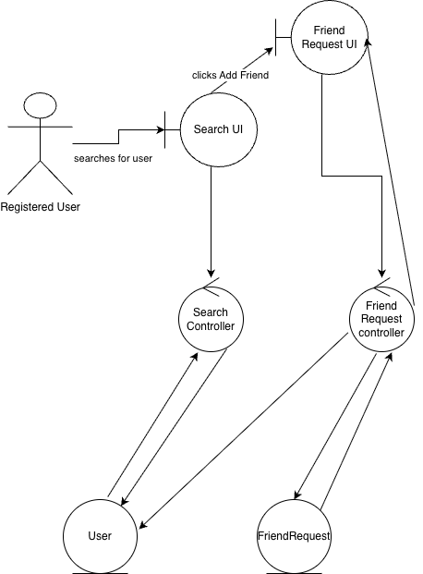
The diagram shows how a registered user sends a friend request. The user enters a search term in the Search UI, which triggers the Search Controller to query the User entity and return matching results. The user then clicks "Add Friend" on a result, which passes the action to the Friend Request UI. The Friend Request Controller first validates the request - checking the User entity to confirm no block or existing friendship applies - then creates a new FriendRequest entity with Status set to Pending. The result is surfaced back to the user through the Friend Request UI.

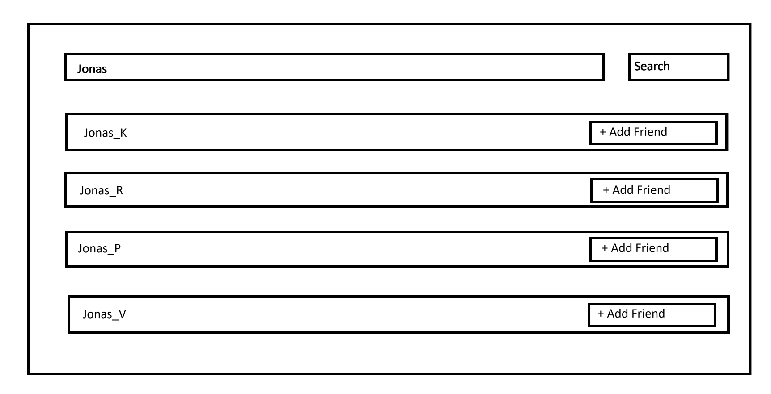
The mockup shows the search screen. The user enters a username and the system returns matching results, each with an Add Friend button. This corresponds to steps 1–3 of the main flow.

3.2 UC-02 Respond to Friend Request
Actors: Registered User
Preconditions:
- User is authenticated
- At least one incoming FriendRequest with Status - Pending exists for this user
Main Flow:
- User opens the friend requests page
- System retrieves all FriendRequest records where ReceiverId = current user and Status = Pending
- System displays the list
- User selects a request and chooses to accept or decline
- System updates FriendRequest.Status to Accepted or Declined
- If accepted, system creates a Friendship record atomically
- System shows the updated result to the user
Alternative Flows:
- The selected FriendRequest no longer exists (was cancelled by sender) → system shows error, refreshes list
Postconditions:
- FriendRequest.Status is updated to Accepted or Declined
- If accepted: a Friendship record exists linking the two users

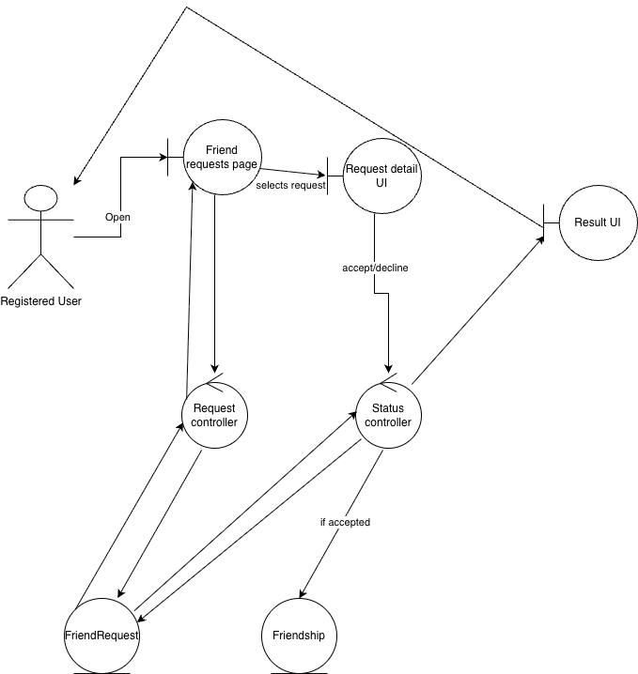
The diagram shows how a registered user responds to a pending friend request. The user opens the Friend Requests Page, which triggers the Request Controller to load all FriendRequest entities where the current user is the receiver and the status is Pending. The user selects a request and chooses to accept or decline via the Request Detail UI, which passes the decision to the Status Controller. The Status Controller updates the FriendRequest entity's status accordingly. If the decision is Accept, the controller also creates a new Friendship entity linking the two users. The outcome is displayed back to the user through the Result UI.

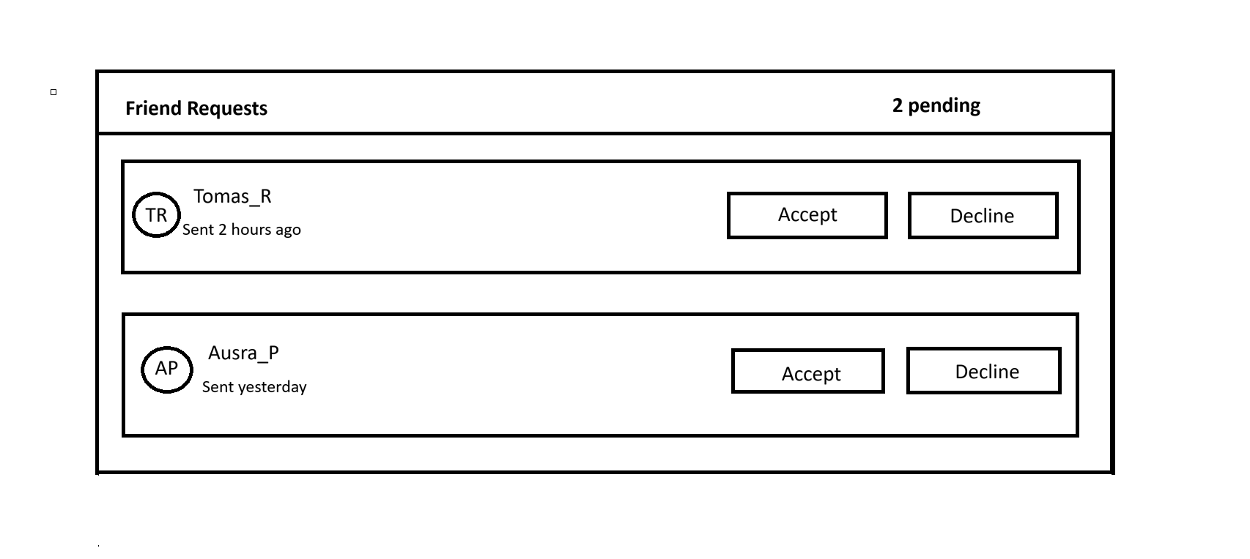
The mockup shows the incoming friend requests page. Each pending request displays the sender's username, timestamp, and Accept/Decline buttons. This corresponds to steps 1–4 of the main flow.

3.3 UC-03 View Friends List
Actors: Registered User
Preconditions:
- User is authenticated
Main Flow:
- User opens the friends page
- System retrieves all Friendship records where UserId or FriendId = current user
- System retrieves the corresponding User records for each friend
- System displays the assembled friends list
Alternative Flows:
- No Friendship records exist for this user -> system shows an empty state message
Postconditions:
- The friends list is displayed, showing usernames of all current friends

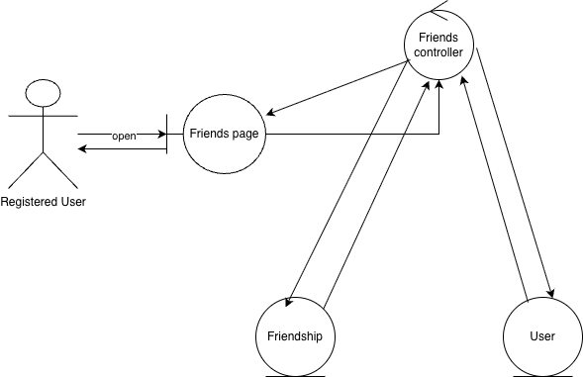
The diagram shows how a registered user views their friends list. The user opens the Friends Page, which triggers the Friends Controller to retrieve all Friendship records associated with the current user. The controller then queries the User entity to resolve the username and profile details for each friend. The assembled list is returned through the Friends Page to the actor.

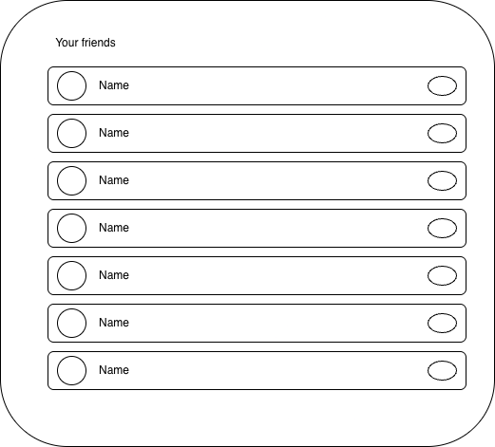

The mockup shows the friends list page. Each row displays a friend's avatar and username. The small circle on the right represents the online/offline status indicator.

3.4 UC-04 Remove Friend
Actors: Registered User
Preconditions:
- User is authenticated
- At least one Friendship record exists for the current user
Main Flow:
- User opens the friends list and selects a friend
- User clicks 'Remove'
- System presents a confirmation dialog
- User confirms the removal
- System deletes the Friendship record
- System refreshes the friends list
Alternative Flows:
- User cancels at the confirmation dialog -> no action taken, friends list unchanged
Postconditions:
- The Friendship record between the two users is permanently deleted

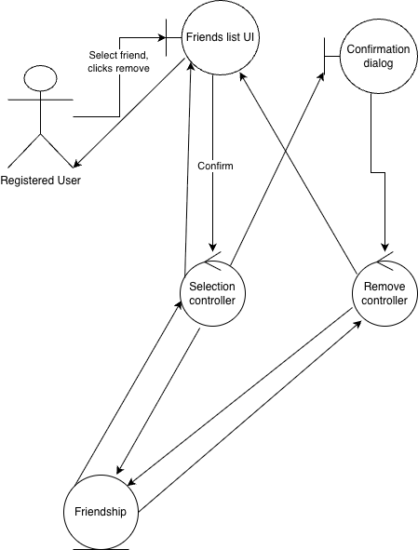
The diagram shows how a registered user removes a friend. The user selects a friend in the Friends List UI and clicks Remove, which routes to the Selection Controller. The controller loads the corresponding Friendship entity and returns its data. The Friends List UI then opens a Confirmation Dialog; if the user confirms, the Remove Controller permanently deletes the Friendship entity and returns control to the Friends List UI, which refreshes. If the user cancels at the confirmation dialog, no further action is taken.

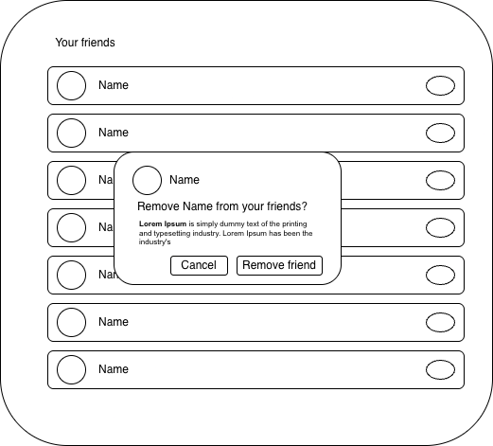

The mockup shows the friends list with a confirmation dialog triggered by clicking Remove. The dialog asks the user to confirm before the Friendship record is deleted, corresponding to steps 3–5 of the main flow.

3.5 UC-05 Block User
Actors: Registered User
Preconditions:
- User is authenticated
- Target user exists and is not already blocked by the current user
Main Flow:
- User opens a target user's profile
- System loads the User entity and checks for an existing Block record
- System displays the profile with a block option
- User clicks 'Block User'
- System cancels any Pending FriendRequest between the two users (Status → Blocked)
- System deletes any existing Friendship record between the two users
- System creates a Block record with BlockerId = current user, BlockedId = target user
- System confirms the action to the user
Alternative Flows:
- Target user has already been blocked -> system shows message, no duplicate Block created
Postconditions:
- A Block record exists with BlockerId = current user, BlockedId = target user
- Any Pending FriendRequest between the two users has Status = Blocked
- Any existing Friendship between the two users is deleted

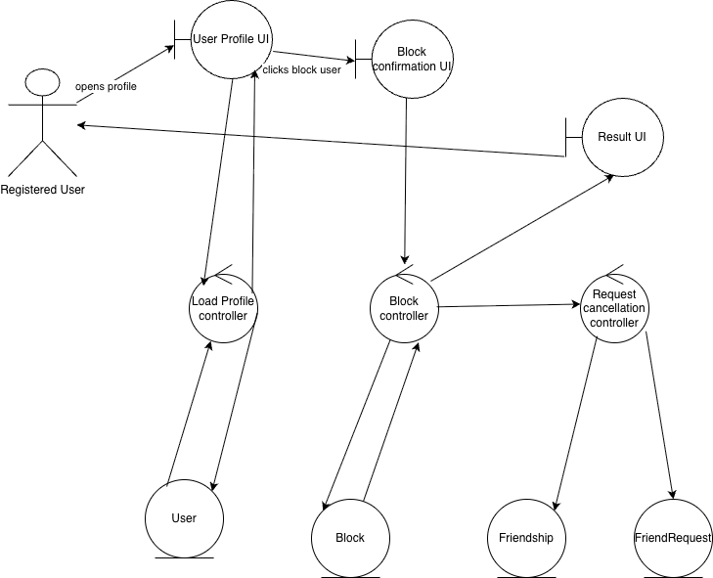

The diagram shows how a registered user blocks another user. The user opens the User Profile UI, which triggers the Load Profile Controller to query the User entity and verify no existing block is in place. The profile is displayed with a block option. When the user clicks "Block User" via the Block Confirmation UI, the Block Controller first goes to the Request Cancellation Controller, which sets any Pending FriendRequest between the two users to Status = Blocked and deletes any existing Friendship record. The Block Controller then creates a new Block entity and confirms the action through the Result UI.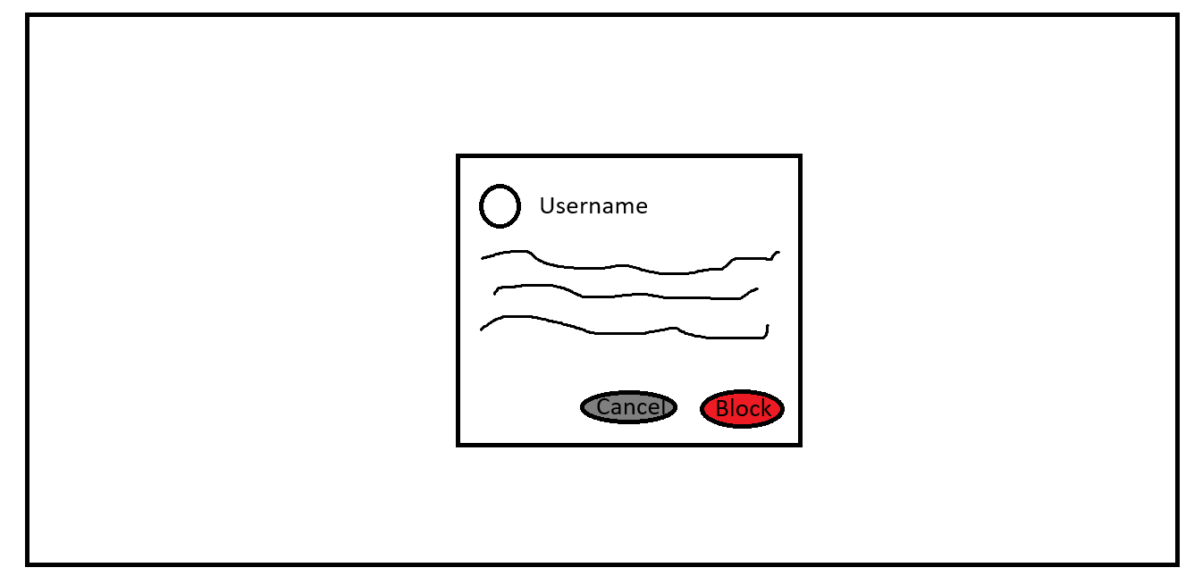

The mockup shows the block confirmation dialog displayed on a user's profile page. The user sees a Cancel and a Block button, corresponding to step 4 of the main flow.

3.6 UC-06 Cancel a Friend Request
Actors: Registered User
Preconditions:
- User is authenticated
- At least one outgoing FriendRequest with Status = Pending exists for the current user
Main Flow:
- User opens the sent requests page
- System retrieves all FriendRequest records where SenderId = current user and Status = Pending
- System displays the list
- User selects a request and clicks 'Cancel'
- System updates FriendRequest.Status to Cancelled
- System confirms the cancellation to the user
Alternative Flows:
- The selected FriendRequest is no longer Pending (already accepted or declined) -> system shows error, refreshes list
Postconditions:
- FriendRequest.Status is updated to Cancelled
- The request is no longer visible to the receiver

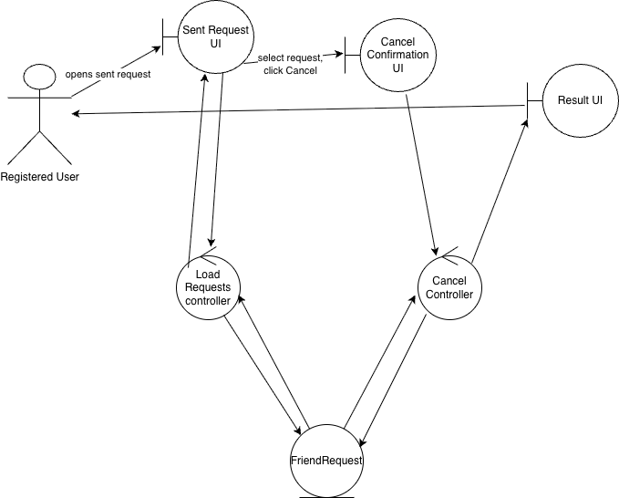
The diagram shows how a registered user cancels an outgoing friend request. The user opens the Sent Requests UI, which triggers the Load Requests Controller to retrieve all FriendRequest entities where the current user is the sender and the status is Pending. The list is returned to the user through the Sent Requests UI. The user selects a request and clicks Cancel via the Cancel Confirmation UI, which passes the action to the Cancel Controller. The controller updates the FriendRequest entity's status to Cancelled and surfaces the confirmation back through the Result UI.

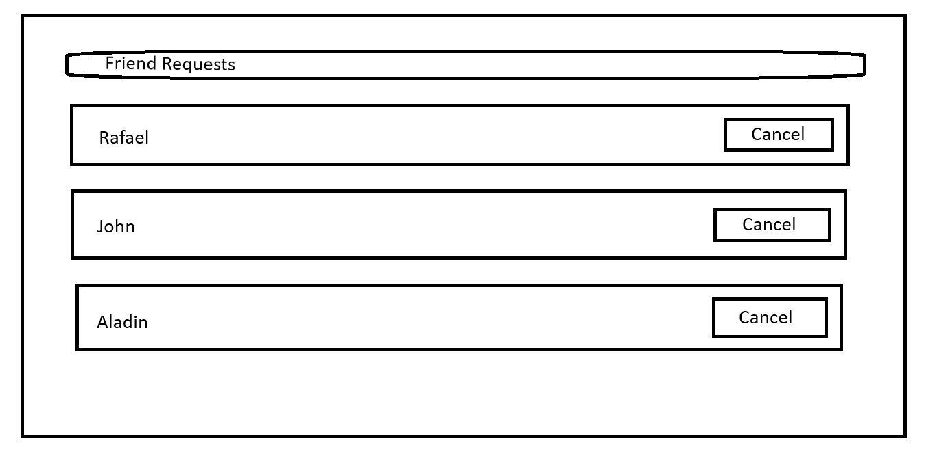
The mockup shows the sent requests page. Each outgoing pending request displays the recipient's username and a Cancel button, corresponding to steps 1–4 of the main flow.

4. Traceability
This section maps the Friend System requirements to the artefacts produced in this iteration: the static model (Section 2) and the use-case robustness diagrams (Section 3). Two cross-reference tables are provided.

Table 4.1 traces each requirement to the specific static model element that realises it and to the use case whose robustness diagram involves it. Table 4.2 cross-references each key static model element to the use-case diagrams where it appears, documenting consistency between the structural and behavioural views.

4.1 Requirements to Static Model and Use Cases
A dash (-) in the Use Case column indicates that the requirement is realised entirely at the static model or service layer; no dedicated robustness diagram was produced for it in this iteration.

Requirement | Static Model Element | Use Case
User search by username | User.Username (indexed) | UC-01
Send a friend request | FriendRequest: SenderId, ReceiverId, Status = Pending | UC-01
A user cannot send a request to themselves | FriendRequest constraint: SenderId ≠ ReceiverId | UC-01
No duplicate pending requests between the same pair | FriendRequest unique constraint on (SenderId, ReceiverId) while Pending | UC-01
Request creation timestamp | FriendRequest.SentAt | UC-01
Accept a friend request | FriendRequest Status → Accepted; Friendship created atomically | UC-02
Decline a friend request | FriendRequest Status → Declined | UC-02
View incoming pending requests | FriendRequest.ReceiverId - list of incoming Pending requests | UC-02
Friendship creation timestamp | Friendship.CreatedAt | UC-02
View outgoing pending requests | FriendRequest.SenderId - list of outgoing Pending requests | UC-06
Cancel an outgoing friend request | FriendRequest Status → Cancelled (sender only, from Pending) | UC-06
Remove a friend | Friendship record deleted | UC-04
View friends list | Friendship: bidirectional via UserId / FriendId | UC-03
Display friend usernames | Friendship, User.Username | UC-03
Display friend online/offline status | User status information entity | -
Display friend active session indicator | User status + Playlist association | -
View a friend's public playlists | User, Playlist | -
Invite a friend to a playlist | Friendship, Playlist | -
Surface friends' active playlist sessions | Friendship, Playlist (active session) | -
Block a user | Block: BlockerId, BlockedId, CreatedAt | UC-05
Blocking cleans up existing connection | Block creation → Friendship deleted; any Pending request → Blocked | UC-05
A blocked user cannot send a friend request | Block: guard on FriendRequest creation (§2.2.2 constraints) | UC-01, UC-05
A blocked user is hidden from search results | Block: User.Username excluded from search results; Playlist hidden | UC-01, UC-05
Friend operations within 1 second | FriendRequest single-row write; Friendship atomic transaction | -
User search within 2 seconds | User.Username index; Block (BlockerId, BlockedId) index | -
All endpoints require authentication | User.Id resolved from JWT | -
Rate limiting on friend requests | FriendRequest.SentAt - sliding-window count at service layer | -

4.2 Static Model Elements to Use Cases
The table below cross-references each domain entity and enumeration from the static model (Section 2) to the use-case robustness diagrams (Section 3) in which it participates. This confirms that every structural element introduced in Section 2 is exercised by at least one behavioural specification, and that every entity manipulation shown in the robustness diagrams is grounded in a defined static model element.

Element | Defined In | Role in Static Model | Referenced in Use Cases
User | 2.2.1 | Sender, Receiver, Blocker, Blocked | UC-01, UC-02, UC-03, UC-04, UC-05, UC-06
FriendRequest | 2.2.2 | Transient lifecycle record | UC-01 (created), UC-02 (Accepted/Declined), UC-05 (Blocked), UC-06 (Cancelled)
FriendRequestStatus | 2.3 | Lifecycle enumeration | UC-01, UC-02, UC-05, UC-06
Friendship | 2.2.3 | Durable bidirectional social bond | UC-02 (created on Accept), UC-03 (read), UC-04 (deleted), UC-05 (deleted on Block)
Block | 2.2.4 | Unidirectional enforcement record | UC-05 (created)
Playlist | 2.2 | Owned collection of songs | UC-03 (active-session indicator)

4.3 Coverage Summary
All in-scope functional requirements and non-functional constraints are mapped to at least one static model element. Six use cases (UC-01–UC-06) are defined in this iteration; each references at least one domain entity from the static model. The three new core entities - FriendRequest, Friendship, and Block - are each linked to at least one requirement and at least one use case, confirming structural coverage of the Friend System change request within this document.

Requirements relating to friend status visibility, public playlist discovery, and playlist invitations are mapped to static model elements but have no dedicated robustness diagram in this iteration; they are realised at the data and service layers and are noted for elaboration in a subsequent iteration.

